SIMULATION AND VERIFICATION OF AND, OR, AND NOT GATES
Aim
To design, implement, and verify the functionality of basic AND, OR, and NOT logic gates using Verilog HDL, and verify the functionality using Synopsys VCS and DVE.
Software Required
- Synopsys VCS
- Synopsys DVE
- Linux Terminal
- Verilog HDL
Boolean Function
The basic logic gates realize the following Boolean functions:
- AND: Y_AND = A . B
- OR: Y_OR = A + B
- NOT: Y_NOT = A'

Theory / Synopsis
Logic gates are the basic building blocks of digital systems. NAND and NOR are universal gates. XOR produces 1 when its inputs differ, while XNOR produces 1 when its inputs are equal.

Files to be Created
File name | Purpose
logic_gates.v | Logic-gate RTL
logic_gates_tb.v | All input combinations and VCD generation

Design / RTL Program
verilog
// gedit basic_gates.v

module basic_gates (
input wire a,
input wire b,
output wire y_and,
output wire y_or,
output wire y_not
);

assign y_and = a & b; // AND gate
assign y_or = a | b; // OR gate
assign y_not = ~a; // NOT gate (inverter)

endmodule

Testbench Program
module tb2;

reg a, b;
wire y_and, y_or, y_not;

// Instantiate the design under test (DUT)
basic_gates uut (
.a(a),
.b(b),
.y_and(y_and),
.y_or(y_or),
.y_not(y_not)
);

initial begin
// ---- VCD dump setup ----
$dumpfile("basic_gates.vcd"); // name of the VCD file to be generated
$dumpvars(0, tb2); // dump all signals in this testbench hierarchy

// ---- Apply all 4 input combinations ----
$monitor("Time=%0t a=%b b=%b | AND=%b OR=%b NOT(a)=%b", $time, a, b, y_and, y_or, y_not);

a = 0; b = 0; #10;
a = 0; b = 1; #10;
a = 1; b = 0; #10;
a = 1; b = 1; #10;

#10 $finish;
#10;
end

endmodule

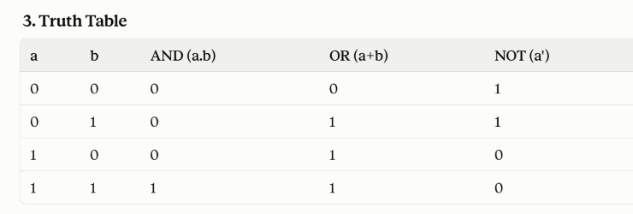

Simulation Procedure

STEP 1 – Open Terminal
Open a terminal in the experiment folder.
bash

STEP 2 – Load Synopsys Environment
source /synopsys/start.sh

STEP 3 – Compile Using VCS
vcs logic_gates.v logic_gates_tb.v -full64
If compilation is successful, VCS generates the simulation executable:
simv

STEP 4 – Run Simulation
./simv
The terminal displays the input combinations and corresponding output F.
A VCD waveform file is also generated:
exp1_boolean_min.vcd

STEP 5 – Open DVE
dve -full64

Other option
dve -full64 &
A DVE environment will open.

DVE Waveform Verification
In DVE:
Open the testbench hierarchy.
Locate the signals:
a
b
y_and
y_or
y_not
Add the signals to the waveform window.
Run/inspect the waveform.
Verify that y_and = 1 only when a=1 AND b=1 — the single combination where both inputs are high.
Verify that y_or = 1 whenever a=1 OR b=1 (any input high forces the output high).
Verify that y_not is always the exact complement of a, regardless of b.
The waveform should agree with the truth table.

Expected Result
The basic logic gates — AND, OR, and NOT — were realized using Verilog HDL:
Y_AND = A.B
Y_OR = A+B
Y_NOT = A'
The design was compiled and simulated using Synopsys VCS, and the functionality was verified using DVE waveform analysis, matching the expected truth table.
Output
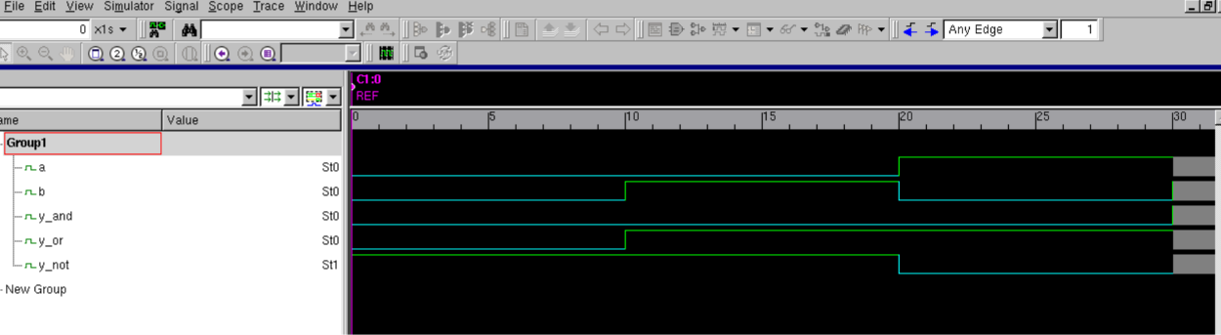
Viva-Voce Questions
- What is a logic gate?
- What are the basic logic gates in digital electronics?
- What is the Boolean expression for an AND gate? An OR gate? A NOT gate?
- Why is the NOT gate also called an inverter?
- What is a universal gate, and how can NAND/NOR realize AND, OR, and NOT?
- What is the purpose of a Verilog testbench?
- Why is a VCD file generated?
- What is the purpose of ./simv?
- What is the purpose of DVE?
- What is the difference between simulation and synthesis?
- What is the difference between $dumpfile and $dumpvars?

